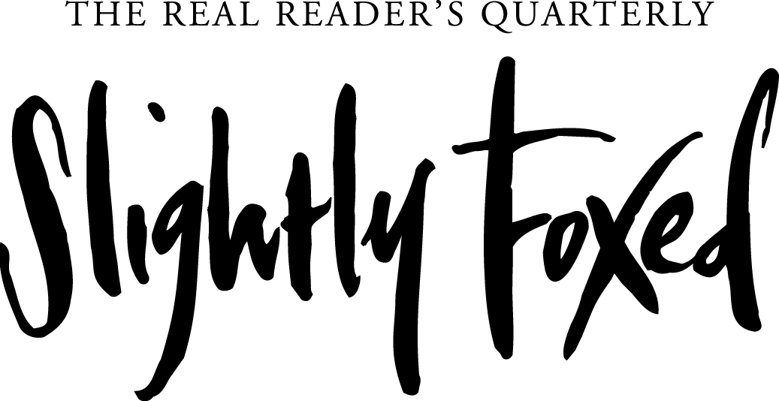
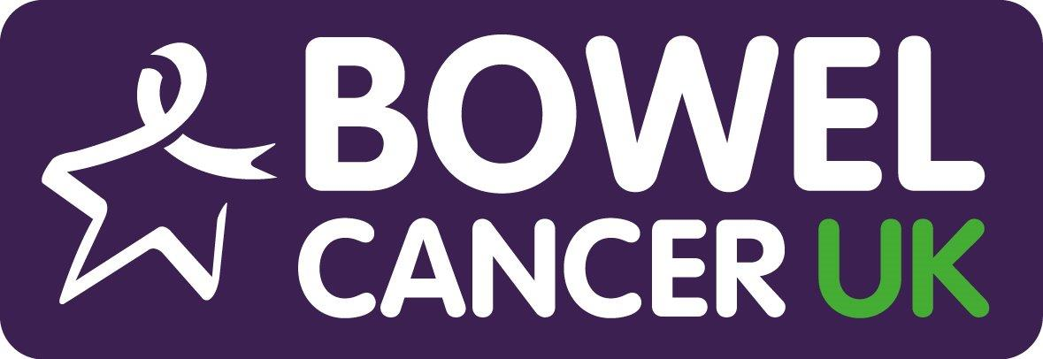

For immediate release, 27 April 2017

Bookish Londoner to cross Europe
in the footsteps of legendary travel writer Patrick Leigh Fermor

“When I first read A Time of Gifts I felt it in my feet. It spoke to my soles. It rang with what in German is called Sehnsucht: a yearning or wistful longing for the unknown and the mysterious. It made me want to stand up and march out - to walk into an adventure.” — Robert Macfarlane, The Gifts of Reading

On Sunday 30 April 2017, 34-year-old Londoner Katy MacMillan-Scott will embark on the adventure of a lifetime: a 600-mile journey from Rotterdam to Budapest, following the route of writer Sir Patrick Leigh Fermor. It is the first leg of a literary pilgrimage that will see her travel all the way to Istanbul over the next few years.

Leigh Fermor, known as Paddy, famously walked across Europe – from the Hook of Holland to Istanbul – between 1933-1935 and wrote about the experience in his trilogy, A Time of Gifts, Between the Woods and the Water and The Broken Road. He was known as one of the leading travel writers of his generation, as well as being famous for his exploits during World War Two. His kidnap of a German commander in Crete was turned into a film, Ill Met by Moonlight, with Dirk Bogard playing Paddy. When he died in 2011, an obituary by the BBC’s Richard Woodward, described him as “a cross between Indiana Jones, James Bond and Graham Greene”.

Katy is not the first to walk in Paddy’s footsteps. British travel writer Nick Hunt followed Paddy’s entire Holland-Turkey route and wrote about it in Walking the Woods and the Water. However, this is only the second time a woman has attempted to travel it in full.

Katy decided to undertake the epic journey following the death of her friend Harriet Clarke from bowel cancer at the age of 32 last March. She credits Robert Macfarlane’s essay, The Gifts of Reading – which is centered around A Time of Gifts – and a talk at the Frontline Club for inspiring her to plan a literary adventure in Harriet’s memory, to celebrate her friend’s life and to raise awareness for Bowel Cancer UK’s Never Too Young campaign.

Katy comments: “Most would agree 2016 had its ups and downs. For me, it will be remembered as the year my friend Harriet died. She was newly married and expecting her first baby when she was diagnosed with advanced bowel cancer. She died just six months later, turning upside down the lives of those who knew and loved her.

“After her death, a friend commented that Harriet had lived wide, if not long. I found myself considering a literary hike in her memory. Harriet and I met studying English literature at university and a shared love of books was one of the foundations of our friendship.

“The last thing we did together was go to a talk on polar explorers. We laughed afterwards about how the panel talked dismissively about ‘lady adventurers’ and exchanged stories about inspirational women like Gertrude Bell and Freya Stark. This lodged in my mind after Harriet died and later, when I read Robert Macfarlane’s The Gifts of Reading, a plan crystallised to go on an adventure Harriet would have loved. It was just after Brexit, and Paddy’s European odyssey struck a chord. It feels like a similar turning point in history, and it is with a mixture of trepidation and excitement that I am setting off on this adventure. I’m curious to see how different my experience will be to Paddy’s, and whether the old hospitality still exists 83 years on.”

Like Paddy, Katy is relying on the kindness of strangers, staying with different people and in different places every night of her trip. Unlike Paddy, she has a full-time job working in arts PR, so is breaking the journey up into sections, walking a bit of the route each year until she reaches her final destination, Istanbul. This first stint will take her across five countries – the Netherlands, Germany, Austria, Slovakia and Hungary – over 20 days. Like Paddy, she will walk most of the way, with the odd train and boat journey to help her along.

Since her shout-out to friends and family for help finding places to stay in January 2017, Katy’s plans have attracted the attention of well-wishers across Europe, with strangers offering bed and board and in one case, by a woman recovering from chemotherapy, the chance to be driven home pillion on a Harley Davidson. Literary magazine Slightly Foxed is amongst her supporters and will be mapping out Katy’s route whilst she is away, posting daily updates and extracts from Paddy’s journals.

Gail Pirkis, Editor of Slightly Foxed, comments:
“The founding members of Slightly Foxed all came from John Murray – Paddy’s life-long publisher – and I worked on Paddy’s final book, Three Letters from the Andes. When we heard about Katy’s adventure, we felt it was a very Slightly Foxed thing to do. We’re delighted to offer our support to a fellow bibliophile and hope Katy’s journey will encourage others to discover Paddy’s work and be inspired to head out on adventures of their own.”

Luke Squires, Director of Fundraising for Bowel Cancer UK, adds:
“We are so grateful that Katy is taking on such an incredible feat of endurance in memory of her friend Harriet. It means so much to us at Bowel Cancer UK, because it means we can continue with our vital work to improve the diagnosis, treatment and care of younger bowel cancer patients through our Never Too Young campaign.

“Every year in the UK over 2,500 under-50s are diagnosed with bowel cancer, which represents a 45% increase in this age group since 2004. Harriet was one of the three out of five people diagnosed under the age of 50 to be diagnosed when the cancer is already in the later stages of disease (stages 3 and 4). The reality is young people are typically diagnosed late because their symptoms can be blamed on other, less serious, but more common diseases. We wish Katy every success and will be supporting her every step of the way, following her journey on Slightly Foxed.”

April is Bowel Cancer Awareness month

To follow Katy’s journey, donate to Bowel Cancer UK or find links to Paddy’s books, visit www.adventuresforharriet.co.uk, or follow @FoxedQuarterly on Facebook, Twitter or Instagram #adventuresforharriet

For more information or images, please contact
Jennie Harrison Bunning at Slightly Foxed:
jennie@foxedquarterly.com / 020 7033 0258

Notes to editors

The route
A map of Paddy’s route, as laid out in A Time of Gifts, is available here. On this trip, Katy will travel between Rotterdam to Nijmegen, Cologne to Bingen and Vienna to Budapest. She will return to cover southern Germany and western Austria next year. Future trips will cover his journey across Hungary, Romania and Transylvania towards Turkey, as outlined in Between the Woods and the Water and The Broken Road.

About Patrick Leigh Fermor
In 1933, at the age of 18, Patrick Leigh Fermor set out on an extraordinary journey by foot - from the Hook of Holland to Istanbul. A Time of Gifts is the first volume in a trilogy recounting the trip, and takes the reader with him as far as Hungary. It is a book of compelling glimpses - not only of the events which were curdling Europe at that time, but also of its resplendent domes and monasteries, its great rivers, the sun on the Bavarian snow, the storks and frogs, the hospitable burgomasters who welcomed him, and that world's grandeurs and courtesies. His powers of recollection have astonishing sweep and verve, and the scope is majestic.

The first two volumes of the trilogy – A Time of Gifts and Between the Woods and the Water – were published to great acclaim and fans clamoured for the final volume. However, though Paddy wished he could finish the trilogy, the words refused to come – curious because he had not only written an early draft of the last part of the walk, but that it predated the other two. It remains unfinished, but The Broken Road – edited and introduced by Colin Thubron and Artemis Cooper – completes his extraordinary journey.

After his walk across Europe, Patrick Leigh Fermor lived and travelled in the Balkans and the Greek Archipelago. In the Second World War he joined the Irish Guards, became a liaison officer in Albania and fought in Greece and Crete - living disguised as a shepherd in the mountains for two years organising resistance activities. He was awarded the DSO and CBE, and a knighthood in the 2004 New Year Honours List. He died in June 2011, at the age of 96. His writing career, spanning over 50 years, includes seven titles available in John Murray paperback.

About Slightly Foxed

With over 13 years and 53 issues in print, the Hoxton publishers of Slightly Foxed: The Real Reader’s Quarterly magazine and growing list of acclaimed limited-edition memoirs have become something of an institution in the literary world.

‘I consider myself fairly well-read but Slightly Foxed never fails to dazzle me upon its arrival. Bookslut

Eclectic, elegant and entertaining, each issue of Slightly Foxed offers 96 pages of lively personal recommendations for fiction and non-fiction books that have stood the test of time. Contributors to the magazine and memoir list are established writers, journalists and booklovers from other fields, including: Diana Athill; Quentin Blake; Margaret Drabble; Rachel Campbell-Johnston; Gerald Durrell; Graham Greene; Irma Kurtz; Amy Liptrot; Penelope Lively; Melissa Harrison; Michael Holroyd; Richard Mabey; Robert Macfarlane; Hilary Mantel; Gavin Maxwell; Dervla Murphy; Sarah Perry; Fiammetta Rocco; Christopher Rush; Posy Simmonds; Dodie Smith; Adam Sisman; Ali Smith, Rosemary Sutcliff.

Slightly Foxed magazine and books are made in England by craftsmen printers. Single issues from £11; subscriptions from £40. Worldwide shipping. Subscriptions include access to the full digital archive and offers from partner organizations, including: Library Club, National Trust and Royal Society of Literature. www.foxedquarterly.com

About Bowel Cancer UK’s Never Too Young campaign
April is Bowel Cancer Awareness month. 2,500 younger people are diagnosed with bowel cancer in the UK every year. While this is only 6% of those diagnosed, this number is slowly increasing. Research by Bowel Cancer UK has shown that younger bowel cancer patients have a very different experience of diagnosis, treatment and care.

Never Too Young is leading change for younger bowel cancer patients. The campaign is giving younger patients a voice and changing clinical practice and policy to stop bowel cancer in people under 50.
https://www.bowelcanceruk.org.uk/campaigning/never-too-young/

